**Task 1 – Generate schema files (Done)**

1. Created an occupancy information template
   * Space rules: 5 office types, 5 meeting room types
   * Occupant behavior rules
   * Holiday rules
2. Created a Ruby class to read data from the template
   * Easier to maintain and update the template
3. Show options on OpenStudio GUI
   * Scan the standard space types in an OSM
   * Apply default space types in the template
   * Allow users to override the default space types by dropdown lists
4. Generate obXML.xml and obCoSim.xml
   * obXML.xml specifies occupancy rules
   * obCoSim.xml specifies simulation start and end dates, and simulation timestep.

**Task 2 – Run Occupancy Simulator (Done)**

1. Save the generated XML schemas in the resource folder
2. Call obFMU.exe to create occupancy schedules

**Task 3 – Read schedule:file to OSM (on-going)**

1. Read schedules from csv
2. Set schedule for each zone
   * OS:Schedule:File
   * OS:PeopleDefinition
   * OS:People
   * OS:SpaceType
   * OS:Space

**Current (set people for spaces via space type)**

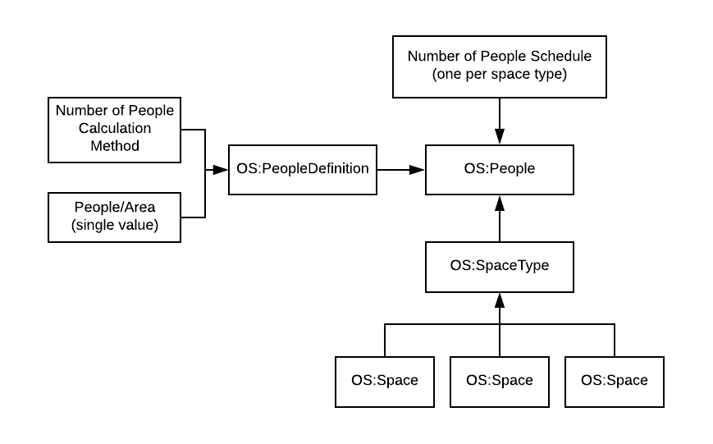

**New**

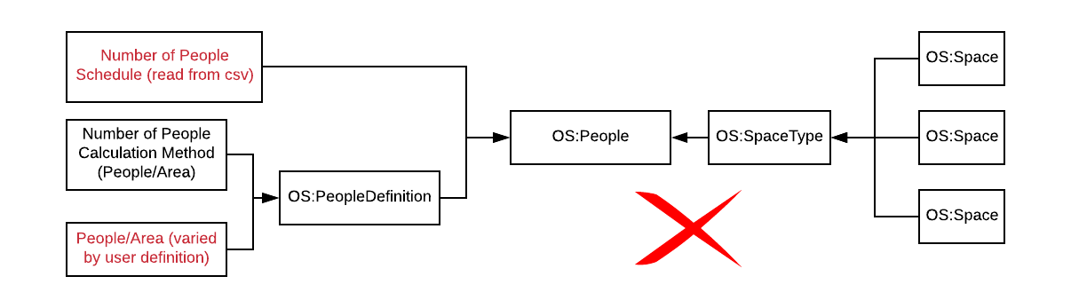

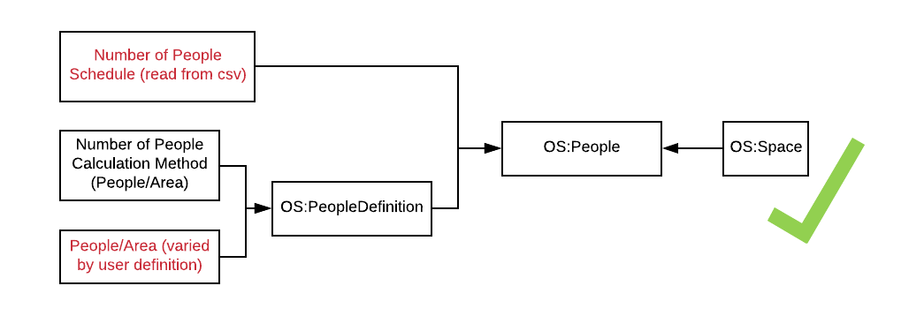

**Steps:**

1. Create OS:Schedule:File objects from csv file.
   1. Tested (Need an OS:External:File object, and multiple OS:Schedule:File objects)
2. Create OS:People:Definition and OS:People pairs
   1. OS:People:Definition – set number of people calculation method to be ‘People/Area’
   2. OS:People:Definition – set ‘People/Area’ value of corresponding space type in the template
   3. OS:People – set number of people schedule to be corresponding schedule:file
   4. OS:People – set activity level schedule name to be obFMU Activity Schedule
3. Set the ‘Space or SpaceType Name’ attribute of each OS:People object to be the corresponding OS:Space object
4. Delete the old OS:SpaceType and OS:People pair (or will it be overwritten automatically?)

How to match the people schedule for each zone? (Create a list of zone indices)

1. Map OS:People to OS:Space/OS:SpaceType

